Architecture Design

Analyzing Swiggy: Bangalore delivery outlet data

By

**Mamta M. Natu**

DOCUMENT VERSION CONTROL

|  |  |  |  |
| --- | --- | --- | --- |
| Date issued | Version | description | Author |
| 22 February 2023 | 1.0 | First Version of architecture design. | Mamta Natu |
| 07 march 2023 | 2.0 | Complete architecture design | Mamta Natu |

**Contents**

1. Introduction………………………………………………………………………………………………………… 04

1.1 What is Architecture Design Document? ………………………………………………….………. 04

1.2 Scope ………………………………………………………………………………………………………………... 04

2. Architecture ………………………………………………………………………………………………………… 05

2. PowerBi Architecture …………………………………………………………………………………………. 05

3. Deployment …………………………………………………………………………………………………………08

3.1 Deployment Options in PowerBi ……………………………………………………………………….08

**1. Introduction**

**1.1 What is Architecture design document?**

Any software needs the architectural design to represents the design of software. IEEE defines architectural design as “the process of defining a collection of hardware and software

components and their interfaces to establish the framework for the development of a computer system.” The software that is built for computer-based systems can exhibit one of these many architectures.

Each style will describe a system category that consists of -

• A set of components (e.g.: a database, computational modules) that will perform a function

required by the system.

• The set of connectors will help in coordination, communication, and cooperation between

the components.

• Conditions that how components can be integrated to form the system.

• Semantic models that help the designer to understand the overall properties of the

system.

**1.2 Scope**

Architecture Design Document (ADD) is an architecture design process that follows a step-by-step refinement process. The process can be used for designing data structures, required software architecture, source code and ultimately, performance algorithms. Overall, the design principles may be defined during requirement analysis and then refined during architectural design work

**2. Architecture**

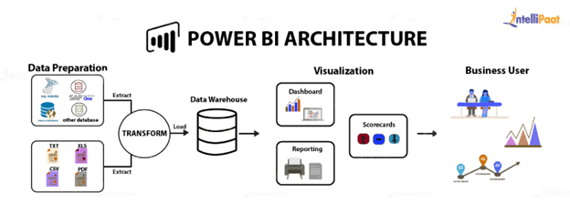

**PowerBi Architecture**

Power BI architecture is a service built on top of Azure. There are multiple data sources that Power BI can connect to. Power BI Desktop allows you to create reports and data visualizations on the dataset. Power BI gateway is connected to on-premise data sources to get continuous data for reporting and analytics. Power BI services refer to the cloud services that are used to publish Power BI reports and data visualizations. Using Power BI mobile apps, you can stay connected to their data from anywhere. Power BI apps are available for Windows, iOS, and Android platforms.

**Power BI Service**

Power BI service is the Software as a Service (SaaS) part of Power BI. It is also known as Power BI Online. To access Power BI Service, you need to log in to Power BI service.

Here is how the home page of Power BI Service looks like once you log in:

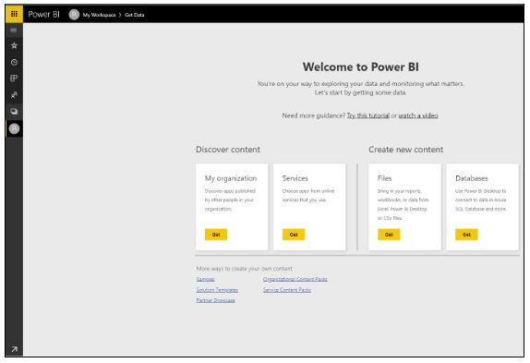

It allows you to connect to data, create reports and dashboards, and ask questions about your data.

**Components of Power BI**

**Power Query**

Power Query is the data transformation and mash up the engine. It enables you to discover, connect, combine, and refine data sources to meet your analysis need. It can be downloaded as an add-in for Excel or can be used as part of the Power BI Desktop.

**Power Pivot**

Power Pivot is a data modelling technique that lets you create data models, establish relationships, and create calculations. It uses Data Analysis Expression (DAX) language to model simple and complex data.

**Power View**

Power View is a technology that is available in Excel, SharePoint, SQL Server, and Power BI. It lets you create interactive charts, graphs, maps, and other visuals that bring your data to life. It can connect to data sources and filter data for each data visualization element or the entire report.

**Power Map**

Microsoft's Power Map for Excel and Power BI is a 3-D data visualization tool that lets you map your data and plot more than a million rows of data visually on Bing maps in 3-D format from an Excel table or Data Model in Excel. Power Map works with Bing maps to get the best visualization based on latitude, longitude, or country, state, city, and street address information.

**Power BI Desktop**

Power BI Desktop is a development tool for Power Query, Power Pivot, and Power View. With Power BI Desktop, you have everything under the same solution, and it is easier to develop BI and data analysis experience.

**Power Q&A**

The Q&A feature in Power BI lets you explore your data in your own words. It is the fastest way to get an answer from your data using natural language. An example could be what was the total sales last year? Once you've built your data model and deployed that into the Power BI website, then you can ask questions and get answers quickly.

**Features of Power BI**

Following are some of the features of Power BI -

**Power BI Desktop**

Power BI Desktop is free software that you can download and install, and it allows you to build reports by accessing data easily. For using Power BI desktop, you do not need advanced report designing, or query skills to build a report.

**Stream Analytics**

Power BI's primary advantage is its support stream analytics. From factory sensors to social media sources, Power BI assists in real-time analytics to make timely decisions.

**Multiple Data Sources**

Support for various data sources is one of the vital features of Power BI. You can access various sources of data such as Excel, CSV, SQL Server, Web files, etc. to create interactive visualizations.

**Custom Visualization**

While dealing with complex data, Power BI's default standard might not be enough in some cases. In that case, you can access the custom library of visualization that meets your needs.

**5 Deployment**

Deployment pipelines is designed as a pipeline with three stages:

**1)Development**

This stage is used to design, build, and upload new content with fellow creators. This is the first stage in deployment pipelines.

**2)Test**

You're ready to enter the test stage after you've made all the needed changes to your content. You upload the modified content so it can be moved to this test stage. Here are three examples of what can be done in the test environment:

Share content with testers and reviewers

Load and run tests with larger volumes of data

Test your app to see how it will look for your end users

**3)Production**

After testing the content, use the production stage to share the final version of your content with business users across the organization.



Reference used:

https://learn.microsoft.com

[www.simplilearn.com/tutorials/power-bi](http://www.simplilearn.com/tutorials/power-bi)